Assessing the Value of Metta on Contentment
Josef Faber
University of the Fraser Valley

Abstract
This study was conducted to determine the validity of Metta meditation and its effects on contentment levels after being exposed to a short session. 20 students from the University of the Fraser Valley participated; each participant was randomly assigned based on the time slot they were available. The experimental group listened to 16 minutes of Metta (loving-kindness) meditation while the control group was asked to sit quietly for 16 minutes. The results showed that the experimental group (M = 38.82, SD = 4.262) was not statistically different than the control group (M = 35.67, SD = 4.444), thus the hypothesis that Metta meditation helps improve levels of contentment was not met. These results, t(18) = 1.614, p > .05, p = .124, two tailed, indicate that more research is needed with longer, more in-depth Metta meditation sessions instead of a one-off session, to realize its full potential.

Assessing the Value of Metta on Contentment
Our days are often filled with loud and distracting people who are too busy to care about the world around them, never really concerned with who they need to walk over to get to where they need to go. This reality can affect our day in ways that people are unable to see until it’s too late. This lack of contentment with one’s life and the frustrations felt for those around us is something that people would rather be able to deal with swiftly without having to carry it with them for an extended period of time. Metta or loving kindness meditation is one method that people are using to feel more contented with themselves and the world. It is a form of meditation that dates back centuries that was designed to help one cultivate a form of love and compassion for all living things. Participants are asked to repeat mantras that evoke thoughts of love and compassion, first for oneself, then a loved one, then the world at large. This cultivation of compassion is said to help people feel more content with their lives and be able to better deal with difficult circumstances. Many studies have been done on Metta meditation but they are often focused on other cognitive issues such as resilience, anxiety and stress.
One such study done by Pidgeon, Ford and Klassen (2013) focused on human service professionals (N = 44) who work with socially disadvantaged young people. The study was made up of mostly female adults. They were trying to determine if Metta meditation would be useful in increasing resiliency in working professionals. They initially exposed half the participants to a Mindfulness with Metta Training Programme (MMTP) for 2 and a half days and then two follow-ups of the same program 1 and 4 months later. The control group did not receive any form of intervention but were offered a 4 hour seminar on mindfulness to attend at the 1 month follow-up. A lack of participation resulted in their data not being included. Both groups were subject to the same pre- and post-test questionnaires that measured self compassion, resilience and mindfulness; each intending to measure coping ability when faced with adversity.
The initial results showed little to no difference between the retreat group and the control group on each measure but differences emerged in each data set at the 1 and 4 month follow-ups. The resiliency levels at the 4 month follow up showed an increase for the experimental group compared to the control group. Within the MMTP group the levels of mindfulness showed improvement immediately after the retreat as well as the 1 and 4 month follow ups. There was also improvement in self-compassion reports after the 1 month and 4 month follow ups. In addition to the previous benefits, 50% of the participants participated in meditative practice outside of the retreat which resulted in higher levels of resilience, mindfulness and self-compassion. Some of the limiting factors such as small sample size, attrition of participants and the lack of follow up data for the control group at 1 month and 4 months contribute to several issues with their results. These findings are difficult to generalize beyond the study itself with the small sample size and narrow demographic. The data does, however, contribute to the usefulness of meditation even when going beyond the scope of its intended purpose.
Weibel, McClintock, and Anderson’s (2016) also looked just outside of what loving kindness meditation (LKM) was initially used for when they looked at its effects on anxiety. They included 60 undergrad student participants primarily made up of Caucasian females with a mean age of 19.1 years old. They used several Likert scale measures to assess the anxiety levels of the participants. The participants were randomly assigned to either the LKM condition or the waitlist control condition. Baseline levels for each group were done prior to the start of the study. Each condition lasted 4 weeks after which they were asked to do a post test assessment. A further follow-up assessment was done 8 weeks after completion in the form of a mail out to the participants. The LKM condition involved four 90 minute recorded sessions per week for 4 weeks. The participants were assigned to three different groups all with different facilitators. Each facilitator was told to do the same techniques for each of their sessions. The participants were also encouraged to practice outside of the study as much as possible.
The results of the study showed that there was no statistically significant difference between the control group and the experimental group when they looked at anxiety. There was, however, a positive result for the measures of self compassion and compassionate love both between groups and within groups. Ultimately Weibel, McClintock and Anderson (2016) were not able to show that LKM was well suited to help alleviate anxiety. It does, however, back up previous research that shows it could be usefulness in treating depression, social anxiety and other disorders that are related to shame and self hatred. With the majority of the participants being young white females, it is difficult to apply these results more broadly. The researchers did attempt to account for teaching biases with three separate facilitators in the LKM condition, resulting in data that was continuous between groups, indicating that it was the actual LKM that helped increase compassion and not just the facilitator. Within the data they collected, they were able to show a positive effect for self-other compassion which is something that may be useful in helping people deal with daily stress.
Sorensen, Steindl, Dingle and Garcia (2018) looked at LKM and its effects on well-being and the ability to deal with stress in daily life. They compared LKM accompanied by music, just LKM and music alone to determine if the mixture of LKM and music, known as Convergence, was a better means of developing well-being than just one or the other. They were split into the three groups: Convergence, LKM, and music. The participants (N = 78) were made up of mostly Caucasian females. Sorensen et al. (2018) pre-tested each participant for baseline levels by gathering information regarding the participant’s mindfulness, distress, fear of compassion, well being and self compassion using several questionnaires. Each questionnaire used a Likert-scale to evaluate each metric. The study was done over three weeks with a follow up four weeks later. Each group did one of the three workshops for 2 hours for three consecutive Saturdays. They were also given material to practice at home along with a diary to track their progress.
The results of the study show that there was a statistically significant change from start to finish of the study in all groups. The well being effect was shown in all groups as well as an improvement in mindfulness. However, the hypothesis that Convergence was a better means of instilling positive affect was not found within the study as the two other methods were shown to be just as successful. Overall the main hypothesis that LKM improves self and other compassion was supported, but is significantly mitigated by the fact that simply listening to music is just as effective as meditation. A potential confound in this study was the fact that the Convergence group listened to specific guitar music while the music only group had their choice of music. It’s possible the chosen music for the Convergence was not to the participants liking, altering the effectiveness of the meditation. Sorensen et al. (2018) state that one of the other potential issues with their study was the fact that simply being in groups was a form of therapy simply through interacting with other people. Interestingly the amount of time that was given to any of the practices did not correlate with higher levels of self/other compassion or less fear of compassion. Overall the study’s lack of diverse participants and the small sample size make it difficult to attribute any significance outside the study. Their hypothesis was not supported, but positive results for LKM were still found. These previous studies look to utilize LKM in different ways, but it is not necessarily designed to help with resiliency, anxiety or stress. It has, however, been shown to help with positive emotions towards the self and others.
The study done by Logie and Frewen (2014) hypothesized that LKM would enhance levels of positive affect towards themselves and others. They included participants (N = 104) from several intro psychology classes, 67% of which were female. It included 3 different groups: mindfulness meditation (MM), LKM, and a control group that was asked to read about the benefits of meditation within the same time constraints as the other groups. Logie and Frewen (2014) used several self-reports for their measures which detailed depression, self-compassion, mindfulness, and a self-other referential processing task. In total there were six Likert-scale tests that were administered along with a self-other referential task that included a mix of negative and positive words that were given alongside their own image or the image of a stranger. The image/word combination was broken down into blocks of time that lasted for roughly 45 seconds. After each block of time they were asked to rate their affect.
Their results showed higher positive affect toward themselves and others when compared to the control group, but no measureable difference between MM and LKM. Their data also showed there was no difference between the control group and the meditation groups with regards to self-referential and other-referential data points. Some of the confounding factors in the study were the lack of diversity within the participants and the difference in treatment of the MM group who had intermittent breaks, unlike every other group. Even with these problems, LKM did show value when looking at positive affect, just like in MM. The difference between LKM and MM is what Fredrickson, Boulton, Firestine, Cappellen, Algoe, Brantley, Kim, Brantley, Salzberg (2017) looked at in their study.
Fredrickson et al.’s (2017) study compared the effects of LKM and MM using 339 participants. The study was broken up into two different groups, each being split into two randomized groups of LKM and MM. In both cases the participants joined a 6-week workshop that had a 1 hour meditative session accompanied by pamphlets for them to practice at home at their discretion. There was also a three week follow-up period in which the participants were asked the same questions after the workshop had concluded. The majority of the participants were female (64%) and white (78%), so the demographical make up of the study is not representative of the general public. The measurement of emotions was done with a 20-item questionnaire on a 5 point Likert scale while the measurement of meditation engagement was done with two simple questions of yes/no and for how much time.
The research showed that those who participated in more daily sessions, either in LKM or MM, were happier in comparison to other participants who engaged less in the activity. It also showed that those who engaged for longer meditation sessions than they would have normally in their daily practice stated higher levels of positive emotions compared to their normal levels. Those who participated in the LKM portion of the study reported higher same-day positive affect as opposed to those in the MM groups. There were several shortcomings in this study with regards to the quality of the data and its validity to be extrapolated outside the study group. The population that participated in the study were mainly white adult females, making this non-representative of the general public. The amount of times that the participants engaged in the meditation outside of the workshop was also not set, so the variability between participants could have very easily been personality based and not based on the actual meditation. The most egregious part of the study was not including the control group’s data into the dataset. The comparison between LKM and MM is interesting, but less so if neither showed any comparative difference to control group positive affect. Shonin, Van Gordon, Compare, Zangeneh, Griffiths (2014) looked to extrapolate data from many studies in their systematic review, resulting in a similar conclusion.
Shonin et al.’s (2014) review consisted of 20 papers that looked at MM, LKM and compassion meditation (CM) and included a combined total of 1312 participants. Their paper took a much closer look at the specifics of Buddhist based meditation and a larger variation in age groups compared to previous work done in the area. The studies that were chosen had participants who took more than one session of LKM or CM, thus allowing for a more trait based conclusion instead of a state based one . The scoring of each study was completed using the Quality Assessment Tool for Quantitative Studies (QATQS) which includes tools that assesses study quality based on several domains including design, confounds, methodology and withdrawals. The average score for the studies was of moderate quality. Each of the studies that were included showed promise for some form of cognitive improvement.
The review supported the idea that within individuals of many age groups LKM and CM could lead to the potential treatment of several mental health issues such as anxiety disorders, stress, and self-compassion. It also showed that there were no significant differences between LKM and CM. However the combination of LKM and MM appeared to have better results than any one meditative practice. The most frequent results observed were positive and negative affect, positive thinking and empathetic accuracy. One of the problems that Shonin et al. (2014) pointed out was the lack of properly definitions of LKM and CM and that a universal definition should be utilized. There were several downfalls of the studies that were chosen, such as a lack of robustness, lack of follow up interviews, small sample sizes, high attrition rates and a lack of vital information that could contribute to the overall seen effects. Even with these issues, trends within the data about LKM and its contribution to self compassion are evident.
Each of these studies touch on LKM in a variety of ways. Pidgeon, Ford and Klassen (2013), Weibel, McClintock, and Anderson’s (2016), and Sorensen et al. (2018) all looked at different potential benefits of LKM, but each of the studies did not explore the underlying value that LKM was initially designed for. Even so, each of the studies did show some positive results when dealing with resilience, anxiety and stress. These results show the potential of LKM beyond its original intent and how studying those factors are important to the growing amount of data on the subject. Shonin et al.’s (2014) review puts into perspective that the data is showing positive results when participants use LKM on a regular basis, thus, overall there appears to be growing evidence for the positive benefits of LKM and its direct effect on positive self-other compassion.
The literature available shows a wide range of potential that meditation and specifically LKM can have on people’s daily lives. It does, however, tend to miss out on the underlying value that LKM can have when going through regular life events. The level of contentment that someone feels has a direct impact on how they deal with everyday ups and downs and the more contented a person is, the more likely they are to be able to move past a difficult situation instead of focusing upon it, which can result in a better mood. This study looks at the level of contentment after a LKM session in comparison to a control group who is asked to sit quietly. It attempted to isolate the actual practice itself from other outside confounding factors that may be at play by having no interaction during the session. This approach along with the questionnaire intended to see actual contentment levels as opposed to indirect levels of emotion that may not correlate with daily contentment. This study hypothesised that participants who participate in a brief, guided Metta meditation session prior to taking a self-report contentment questionnaire will report higher levels of contentment than participants who sit in silence prior to taking a self-report contentment questionnaire.
Method
Design
This study used a simple independent groups design with two levels of the independent variable (The absence or presence of Metta Meditation: Presence of Metta meditation, Absence of Metta meditation). The dependent variable was contentment and was measured by using a 5-point Likert scale questionnaire (see Appendix B) that assesses the current level of contentment. The questionnaire also included questions regarding age, gender, experience and prior knowledge.
Participants
There were 20 students that participated in this study on Metta meditation, 9 in the control group and 11 in the experimental group. They were selected from the psychology subject pool at the University of the Fraser Valley where they signed up via SONA, the online psychology research participation system as well as participants within the classroom. The SONA participants received a 1% course credit towards their psychology class. The participants were assigned to each condition based on the timeslot they choose when they initially signed up to the study.
Materials
Audio . An app on a cell phone called Waking Up and an external Bluetooth speaker was used to initiate the Metta meditation session to guide the participants. The Metta meditation session involved concentration on the well being of others and themselves. The audio guided the participants through several steps of concentration on someone that they truly care for, their family, the population at large and finished with a focus on themselves and their own well being. Each time they were asked to think of others or themselves as their best selves and as happy as they can be; to wish them the best life they could live with all the happiness they could ever want. Its core message was one of loving kindness to everyone past present and future. It was a 16 minute pre-recorded session that was narrated by Sam Harris. The participants were told to relax and were then guided through several thought experiments while thinking the most positive thoughts they could about whomever they are concentrating on.
Levels of contentment questionnaire. A questionnaire was used in the testing portion of the study that included 10 questions regarding their contentment level. These questions asked them about their contentment in several ways, including their present levels of how they feel, their current direction in life, and if they presently felt like they would have changed anything in their life. Each question was on a Likert scale out of 5 where (1) = “Absolutely Agree”, (2) = “Mostly Agree”, (3) = “Agree”, (4) = “Mostly Disagree” and (5) = “Strongly Disagree”. They chose the wording that best described their experience and then each answer was correlated with the corresponding numerical value. The highest possible score was 50 points and the lowest was 10 points. Information included in the data collection questionnaire included questions about their age, gender and general questions regarding their personal experience with the session, and their level of knowledge and experience with meditation. Some of these questions addressed their commitment to the session, their prior experience with meditation and prior knowledge of the guide to determine potential confounds within the study.
Procedure
Both participant groups sat down and had their attendance taken and then read the informed consent form (see Appendix C) that was handed out to them. They were notified of their right to leave and still gain credit for showing up and then the study began. The first group was asked to close their eyes and then experienced the Metta meditation session for roughly 16 minutes. After the session, each participant was given the questionnaire to complete. The second group was asked to sit quietly for 16 minutes with their eyes closed. After which each participant was given the questionnaire to complete. Both groups closed with a debriefing (see Appendix D) explanation and were asked if there are any further questions. Once that was all done, they were thanked for participating and they were free to leave the room. Their participation mark was then recorded on the SONA website for those who participated and a print off of the participation list is included (See Appendix E).
Results
This study used an independent samples t-test to determine whether those who were exposed to Metta meditation (N = 11) were more likely to feel contentment as opposed to those who were asked to sit in silence (N = 9). The assumptions were all met for the t-test as indicated by the histogram’s distribution of scores. There was also an interval scale used to measure the level of content, satisfying the assumption of interval/ratio data. There were no extreme outliers within the data. The assumption of independence of observation was met, as each participant had no knowledge of the test prior to beginning and no communication occurred during the experiment. The control and the experimental groups also did not meet at any point during the study. The equality of variance was met using Levene’s test, F=.413, p > .05, p = .529, which showed no significant violations, meaning the equal variance assumed version of the t-test was used. The mean contentment score for the Metta meditation group (M = 38.82, SD = 4.262) did not differ significantly from the mean scores in the control group (M = 35.67, SD = 4.444). The results, t(18) = 1.614, p > .05, p = .124, two tailed, did not show any statistical differences between the two groups (see Appendix F for SPSS results).
Discussion
This study looked to narrow in on the levels of contentment within individuals after they have listened to a short, 16 minute Metta meditation session. The hypothesis that they would rate higher levels of contentment compared to the control group who sat quietly for 16 minutes was not met. There were no statistically significance differences between the two groups. The average score for the experimental group was slightly higher than the average for the control group; however, because the value did not meet the threshold of significance, nothing can be attributed to the small difference other than margin of error. Although none of the other studies directly measured levels of contentment within their cohorts, even similar results did not match the findings of this study. Logie and Frewen’s (2014) paper measured positive affect, which correlates closely to contentment, but their positive results for LKM and MM were not matched within this studies inconclusive result.
There are several important considerations that should be looked at in this study when viewing the results. These include the randomization of participants, age differences between the two groups, diversity of participants, small sample size, lack of pre-test prior to the start of the study, short one time meditation session, and lack of follow-up data. One potential confound that was initially thought to be a potential issue was knowledge of who the guide, Sam Harris, was and that that knowledge, either in a positive or negative light, could have altered how the participants took to the meditation session. None of the participants noted having any knowledge of who he was, so it did not end up being a confounding problem.
This study was originally designed to have about 20 participants taken from the University of the Fraser Valley (UFV) SONA pool of participants, but the lack of signups did not allow for that possibility. So half the group was then taken from a classroom setting that was not controlled nor randomized. That lack of control over who went into which group could have contributed to inconsistent results. The same issue also contributed to a fairly large difference in the average age of each group, where the control group’s median was 21.1 years old and the experimental group was 32.6 years old. Although it ended up that the ratio of male and females was almost identical, the large average age difference between the two groups could have a strong effect on the results, skewing the data in unforeseen ways.
When looking at the potential of broadening these results to the general public we can look at Fredrickson et al.’s (2017) study as a better guide for how to do so. Although they ended up with a higher female to male ratio, they were able to get a better representation of the general population by advertising to the general public and getting random participants to engage in their study. When we then look at similar studies to this one, Logie and Frewen’s (2014) and Weibel, McClintock, and Anderson’s (2016) work also had to rely on psychology students in a university setting. This carries with it the same issue that this study had, as it to, relied strictly on university participants who are not a clear representation of the general public. The motivations, lower average age, and intentionality of those who have chosen to go to a university setting do not match that of the public at large.
One of the larger contributing factors to the lack of quality data is the small sample size that was used in this study. This is a recurring issue in many psychology studies as can be seen in the majority of the papers referred to in this study. Sorensen et al.’s (2018) study only used 78 participants, Weibel, McClintock, and Anderson’s (2016) had 71 participants, Logie and Frewen (2014) had 104 participants, Pidgeon, Ford and Klassen (2013) started with 44 participants but only ended up with 36 participants after several of them did not complete the questionnaires. This studies small sample size (N = 20) that was selected from a small subset of the population, UFV, which was then selected from an even smaller subset of that population, the psychology department within UFV, creates a tenuous combination of small sample size and low diversification. This makes extrapolation of the data almost impossible beyond the study itself, as such, recommendations for future studies will be discussed below.
What the participant’s baseline measure levels are just prior to the start of a study is important information that can help determine how well the independent variable affected the dependent variable. Pidgeon, Ford and Klassen (2013) took this into consideration in their study as they measured the levels of resiliency, mindfulness and self-compassion of each participant, allowing them to see which measures were truly affected and which were not. This data is helpful in determining not only a between groups comparison but also a within groups comparison. That data can also help show valuable results when contrasting the two datasets. As it was, in this study, the baseline levels of contentment of the participants were not taken into consideration due to time constraints. This means that each group’s potential improvement of contentment was unknown. There could have been a more significant change seen had there been a test prior to the start of the control and experimental sections of the study. Unfortunately without that data, it is unknown if there was any changes in each participants levels of contentment from the start to finish of the study.
When looking at the large amount of time and commitment to the meditation sessions that was put into the studies by Weibel, McClintock, and Anderson’s (2016) and Sorensen et al. (2018), we can see a distinct lack of time allocation (only 16 minutes) within this study to the Metta meditation. Weibel, McClintock, and Anderson’s had each group participate for 90 minutes in 4 sessions a week while Sorensen et al. had participants participate in a 2 hour long session as well as participating in sessions at home at their own leisure. It must also be taken into consideration that the 16 minute long meditation was guided from an app on a phone, which means that there was no personalized touch to the session itself. When combined with the short meditation session, it can be said that the participants could not fully appreciate the commitment that meditation may require, especially one such as Metta meditation where continual mantra chanting inside ones mind is key to its fulfillment. The practice itself needs repetition through many sessions as well as a commitment to the ideology behind it. Without the daily or weekly follow-up sessions, it is extremely difficult to determine the effectiveness that such a short, single session can have on an individual.
One of the last things to consider, in combination with the short time frame of the single meditation session, is the lack of follow up questionnaire data that should accompany this type of research. Weibel, McClintock, and Anderson’s (2016) used email and phone calls to follow up with their participants after the initial study was completed to round out their data and to see if there were any lasting effects of the Metta meditation. The longevity of the impact could further substantiate the validity of the meditation if it were shown to have a lasting impression upon the participants. This was also done with the Sorensen et al. (2018) study where they emailed their participants 4 weeks after the study concluded to enhance their own data. Had the participants within this study been given the option to practice meditation at home and a follow-up survey been used to collect the data, it could have helped to make a better case for the usefulness of Metta meditation.
The overall results of the study did not match that of the hypothesis, but the open ended questionnaire did give some marginally interesting results. Those participants who were a part of the experimental group that had previous meditation experience (of any kind) had an overall higher average contentment score than those who had not had any previous experience with meditation in any context. This could have meant a stronger desire to commit to the 16 minute session compared to the others that had no prior experience. This would indicate a potential type of personality that may be drawn to meditation over other types. However the data shows that all but one individual stated that they were committed to the meditation session but the depth of that commitment may differ for those who have had prior experience. None of the experimental group participants indicated any knowledge of Metta meditation on the questionnaire expect one individual, who stated that they have had experience with a similar practice. Unfortunately, even the slight improvement of those who had prior experience was not statistically significant.
The point of this study was to help add more detail and data to the overall content that exists within Metta meditation literature but the small sample size and the short meditation session meant a lack of any conclusive data and an inability to support the hypothesis that Metta meditation has any effect on the levels of contentment of individuals. Further study is recommended in the form of a more randomized control study that utilizes the general population instead of a small subset of individuals from a university. The need for diversity of ethnicity, age, gender and differing mindset in future studies is an important component to these types of studies if they are to be generalized beyond the study itself. It is also recommend that longer sessions be used over an extended time period to help facilitate a change in the way of thinking that individuals may have as it is the lifelong practice of Metta meditation that is said to really help individuals see a difference in their contentment levels in everyday life.

References
Barnhofer, T., Chittka, T., Nightingale, H., Visser, C., & Crane, C. (2010). State effects of two forms of meditation on prefrontal EEG asymmetry in previously depressed individuals. Mindfulness, 1(1), 21–27. https://doi-org.proxy.ufv.ca:2443/10.1007/s12671-010-0004-7
Fredrickson, B. L., Boulton, A. J., Firestine, A. M., Van Cappellen, P., Algoe, S. B., Brantley, M. M., … Salzberg, S. (2017). Positive emotion correlates of meditation practice: A comparison of mindfulness meditation and loving-kindness meditation. Mindfulness, 8(6), 1623–1633. https://doi-org.proxy.ufv.ca:2443/10.1007/s12671-017-0735-9
Logie, K., & Frewen, P. (2015). Self/other referential processing following mindfulness and loving-kindness meditation. Mindfulness, 6(4), 778–787. https://doi-org.proxy.ufv.ca:2443/10.1007/s12671-014-0317-z
Pidgeon, A. M., Ford, L., & Klaassen, F. (2014). Evaluating the effectiveness of enhancing resilience in human service professionals using a retreat-based mindfulness with metta training program: A randomised control trial. Psychology, Health & Medicine, 19(3), 355–364. https://doi-org.proxy.ufv.ca:2443/10.1080/13548506.2013.806815
Shonin, E., Van Gordon, W., Compare, A., Zangeneh, M., & Griffiths, M. D. (2015). Buddhist-derived loving-kindness and compassion meditation for the treatment of psychopathology: A systematic review. Mindfulness, 6(5), 1161–1180. https://doi-org.proxy.ufv.ca:2443/10.1007/s12671-014-0368-1
Weibel, D. T., McClintock, A. S., & Anderson, T. (2017). Does loving-kindness meditation reduce anxiety? Results from a randomized controlled trial. Mindfulness, 8(3), 565–571. https://doi-org.proxy.ufv.ca:2443/10.1007/s12671-016-0630-9

Appendix A
Script
Hi, I want to start by thanking everyone for participating in my study today. My name is Josef Faber and I am going to lead you through this study. I will begin by taking attendance and then handing out informed consent form. [Attendance] Alright so once again, I thank you for participating; I will now hand out the informed consent form and then read it aloud and take any questions you may have. [Hand out Informed Consent Form] So, once we have gone over any questions that may arise, please sign the form at the bottom of the sheet, assuming you agree to participate [Read Informed Consent Form]. Are there any questions? [Take questions] Please be aware that you may choose to leave prior to beginning the study and still receive participation credit. Alright, so please be sure to sign the sheet and I will come by and collect them from you. [Collect forms] As I am sure most of you are aware, you will receive a participation credit to go towards your 100 level course which I will be inputted into the SONA system after the study has concluded. If you do not receive any credit, please inform your professor so that they can notify me and we can rectify the problem.
In this study we will be sitting quietly with our eyes closed (either):
- While listening to a guided Metta meditation session for the next 16 minutes.
- For the next 16 minutes.
Please try and relax during this time as much as possible.[16 minutes has elapsed] Alright, so that’s it for that portion of the study, I will now hand out the questionnaire for you all to fill out. I’d like to make this point as clear as possible, the responses from this questionnaire are completely anonymous, so please do not put your names on the sheets, they are anonymous. Once you are done filling out the sheet, please wait until everyone else is finished, at which point I will come by and collect the questionnaires from you. After that is done we will go over any other questions that you may have prior to going over the debriefing after which everyone will be free to leave. [Hand out questionnaire] Please begin filling out the questionnaire. [Ask if everyone is complete – if all complete, collect questionnaire] Alright, thank you for filling these out, we will quickly go over the debriefing form, which I will read aloud.
[Distribute debriefing form] [Read debriefing form aloud] Alright, so a big thank you to everyone for participating; does anyone have any questions before we go? [Take questions] Perfect, thank you so much for helping me out. You are free to leave, have a good day!

Appendix B
Questionnaires
Questionnaire (Circle Your Choice)
1. | I feel like living every day to its fullest potential:
 | Absolutely Agree | Mostly Agree | Agree | Mostly Disagree | Strongly Disagree
2. | I feel like I will achieve my goals:
 | Absolutely Agree | Mostly Agree | Agree | Mostly Disagree | Strongly Disagree
3. | I currently lack direction in my life:
 | Absolutely Agree | Mostly Agree | Agree | Mostly Disagree | Strongly Disagree
4. | I currently have everything I need:
 | Absolutely Agree | Mostly Agree | Agree | Mostly Disagree | Strongly Disagree
5. | I feel that the world is not going in the right direction:
 | Absolutely Agree | Mostly Agree | Agree | Mostly Disagree | Strongly Disagree
6. | I feel that my education is worthwhile:
 | Absolutely Agree | Mostly Agree | Agree | Mostly Disagree | Strongly Disagree
7. | I would prefer to be anywhere but here right now:
 | Absolutely Agree | Mostly Agree | Agree | Mostly Disagree | Strongly Disagree
8. | If I had the chance right now, I would change most everything in my life:
 | Absolutely Agree | Mostly Agree | Agree | Mostly Disagree | Strongly Disagree
9. | I feel like every moment in life is worth living:
 | Absolutely Agree | Mostly Agree | Agree | Mostly Disagree | Strongly Disagree
10. | I am feeling content:
 | Absolutely Agree | Mostly Agree | Agree | Mostly Disagree | Strongly Disagree

General Questionnaire
Age: _________ | Gender: | Other | Female | Male

Did you engage in the 16 minute session?
Have you heard of Metta (Loving Kindness) Meditation before this study? If so, how did you feel about this method?
Have you ever tried any type of meditation prior to this study? If so, which type?
Have you ever heard of the neuroscientist Sam Harris? If so, how do you feel about him?
General Questionnaire
Age: _________ | Gender: | Other | Female | Male

Did you engage in the 16 minute session?
Have you ever tried any type of meditation prior to this study? If so, which type?

Appendix C
Forms
Informed consent form
Informed Consent
Student Investigator Information
Name: Josef Faber
Email address: Josef.faber@student.ufv.ca
Thank you for your interest in participating in this research study. UFV and those conducting this project subscribe to the ethical conduct of research and to the protection at all times of the interests, comfort, and safety of participants. This form, and the information it contains, are given to you for your own protection and full understanding of the procedures.
Your signature on this informed consent form will signify that:
• you have received a document which describes the procedures, possible risks, and benefits of this research project
• you have received an adequate opportunity to consider the information in the document
• you voluntarily agree to participate in this project.
Please read this form and ask any questions you may have before agreeing to be in the study.
Time Commitment: Your participation in this study will require approximately 30 minutes.
Risks: This study has been designed to be a straightforward investigation in which there are no known risks. Your participation in this study is entirely voluntary, and you may refuse to answer individual questions or to engage in individual activities. You may also discontinue all participation in this study at any time without losing your research credit.
Benefits: You will earn 1% OR 2% toward your psychology 101 or 102 class in exchange for your participation. By participating in this study, you will have the opportunity to learn about psychological research, as well as the topic being investigated.
Confidentiality: The data collected in this experiment will be anonymous. You will not be required to write your name or any other identifying information on the research materials. Your name will not be stored with the data, and this consent form will be stored separately from your data. Reports of this experiment will not include individual data in a form by which you could be identified. Materials will be stored in a secure location and will be destroyed after the completion of the study.
Participant Information: You will be one of approximately 20 participants recruited from the psychology subject pool and will be tested in a group setting.
Concerns about any aspect of this study may be referred to:
Adrienne Chan  Acting Associate Vice-President,  Research and Graduate Studies  604-557-4074  Adrienne.Chan@ufv.ca | Kim Striebel  Psych 202 Course Professor  Kim.Striebel@ufv.ca | Melissa Hoeppner  Psych 202 Lab Instructor  Melissa.Hoeppner@ufv.ca

Description of Research Study for Informed Consent
Psychology 202

Title of Project: Content Effects
This study is being conducted by: Josef Faber
Procedures:
If you agree to be in this study, we would ask you to do the following things:
Sit quietly, close your eyes and listen to a 16 minute meditation session. The session will involve you listening to a recorded audio session that will guide your thoughts towards those you care for and the general public with a focus on wanting them to live happy lives. After which you will be asked to fill out a short questionnaire. The questionnaire will contain 10 questions pertaining to your experience today.
I will be happy to answer any non-influencing questions about this study before we begin, but some questions may need to be answered after its completion as they could alter the outcome of the study. After its completion I will explain my hypothesis and give further explanation of the study itself.
I have read the Letter of Information, have had the nature of the study explained to me and I agree to participate. All questions have been answered to my satisfaction. In signing this form, I certify that I am 18 years of age or older or am between 16 and 18 and have sufficient understanding of the research study. According to Health Canada, "young people between 16-18 years of age with sufficient understanding are able to give their full consent to participate in research independently of their legally authorized representative" (http://www.hc-sc.gc.ca/sr-sr/advice-avis/reb-cer/applic-demande/_form_docs/e-eng.php).

Participant name (please print)
Signature of participant date

I certify that I have presented the above information to the participant
Signature of student researcher date

Description of Research Study for Informed Consent
Psychology 202

Title of Project: Content Effects
This study is being conducted by: Josef Faber
Procedures:
If you agree to be in this study, we would ask you to do the following things:
Sit quietly, close your eyes for roughly 16 minutes. After which you will be asked to fill out a short questionnaire. The questionnaire will contain 10 questions pertaining to your experience today.
I will be happy to answer any non-influencing questions about this study before we begin, but some questions may need to be answered after its completion as they could alter the outcome of the study. After its completion I will explain my hypothesis and give further explanation of the study itself.
I have read the Letter of Information, have had the nature of the study explained to me and I agree to participate. All questions have been answered to my satisfaction. In signing this form, I certify that I am 18 years of age or older or am between 16 and 18 and have sufficient understanding of the research study. According to Health Canada, "young people between 16-18 years of age with sufficient understanding are able to give their full consent to participate in research independently of their legally authorized representative" (http://www.hc-sc.gc.ca/sr-sr/advice-avis/reb-cer/applic-demande/_form_docs/e-eng.php).

Participant name (please print)
Signature of participant date

I certify that I have presented the above information to the participant
Signature of student researcher date

Ethics Approval
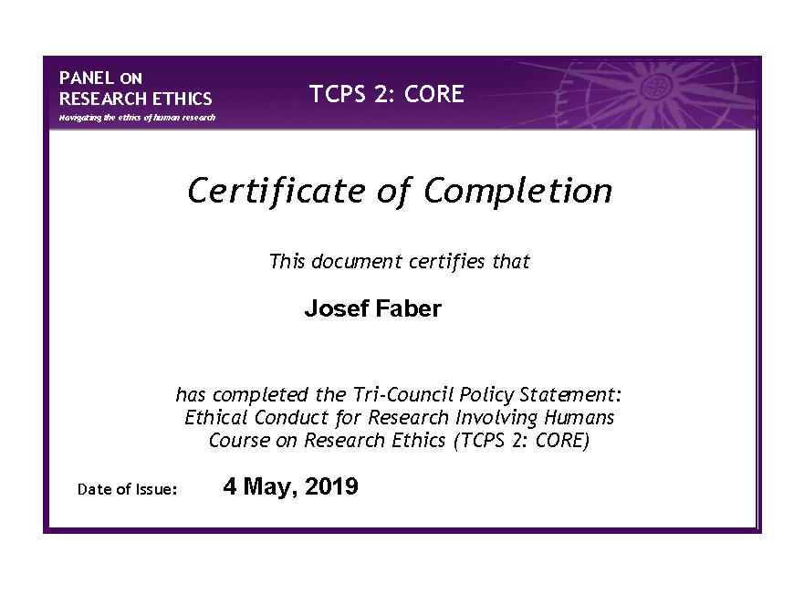
Appendix D
Debriefing form
UNIVERSITY OF THE FRASER VALLEY PARTICIPANT DEBRIEFING FORM
The Effects of Metta Meditation on Contentment
Thank you for participating in this study of the effects of Metta meditation. Metta meditation or loving-kindness meditation is the focus of good-will for all others in the world no matter who they are. Its main purpose is to be content with oneself within the world and to wish nothing but love to all others, no matter who that may be. The purpose of this experiment was to determine whether exposure to a session of Metta meditation would help to create an increased sense of contentment within participants. There have been a fair amount of studies on this subject but the basic question of contentment is often overlooked. In this study I am strictly attempting to associate levels of contentment with exposure to Metta meditation.
In this study, you were in one of two separate groups. The first group was exposed to 16 minutes of Metta meditation guided by Sam Harris via his app Waking Up. The participants were then given a questionnaire with 10 questions designed to measure levels of contentment. The second group was asked to sit quietly with their eyes closed for 16 minutes. They then filled out the same questionnaire as participants in the first group.
My hypothesis was that participants who participate in a brief guided Metta meditation session in the first group will rate higher levels of contentment after the session than those in the second group who do not participate in the Metta meditation session. If there is support for my hypothesis then future studies may be carried out to determine how high that increased level of contentment can go with prolonged sessions of Metta meditation. These findings could help individuals to feel better about their day and the world around them, leading to better emotional management. The findings may also help to facilitate better techniques in counselling and therapeutic situations for psychologists and psychiatrists.
If you are interested in learning the final outcomes of this study, please contact me by email at josef.faber@student.ufv.ca, and I will gladly share the results.
Due to the ongoing nature of this research study, please refrain from discussing the experiment with other possible participants until the study is concluded. Your cooperation is paramount to the success of the study, and is very much appreciated.
If you have any concerns about any aspect of this study, please refer to the following contact:
Adrienne Chan
Acting Associate Vice-President,
Research and Graduate Studies
604-557-4074
Adrienne.Chan@ufv.ca

Appendix E
SONA systems participant attendance list 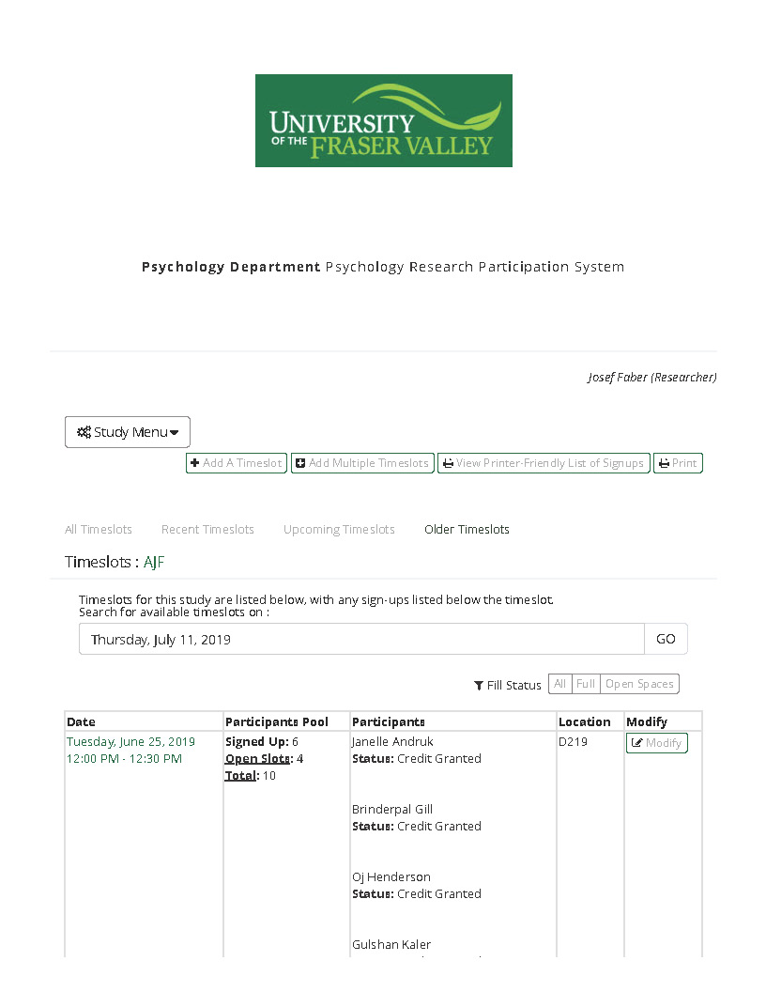
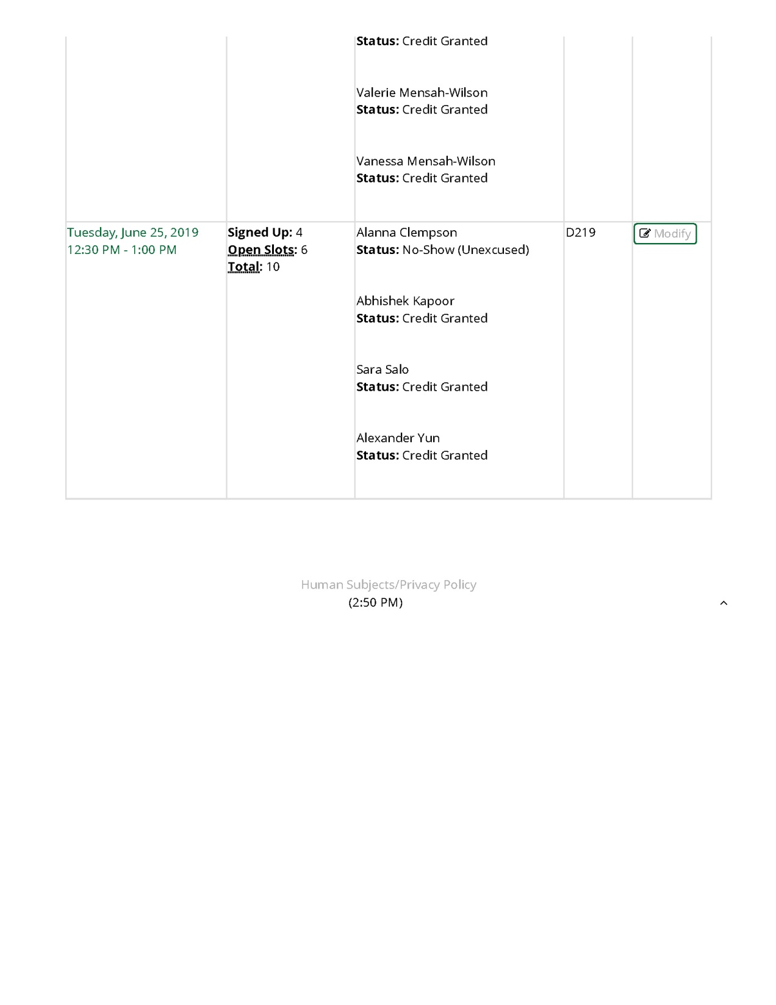

Appendix F
SPSS Output
GRAPH
/HISTOGRAM(NORMAL)=Total.
Graph
Notes
Output Created |  | 27-JUN-2019 15:12:47
Comments
Input | Data | C:\Users\300160287\Downloads\SPSS_file.sav
 | Active Dataset | DataSet2
 | Filter | <none>
 | Weight | <none>
 | Split File | <none>
 | N of Rows in Working Data File | 20
Syntax |  | GRAPH  /HISTOGRAM(NORMAL)=Total.
Resources | Processor Time | 00:00:00.94
 | Elapsed Time | 00:00:06.03

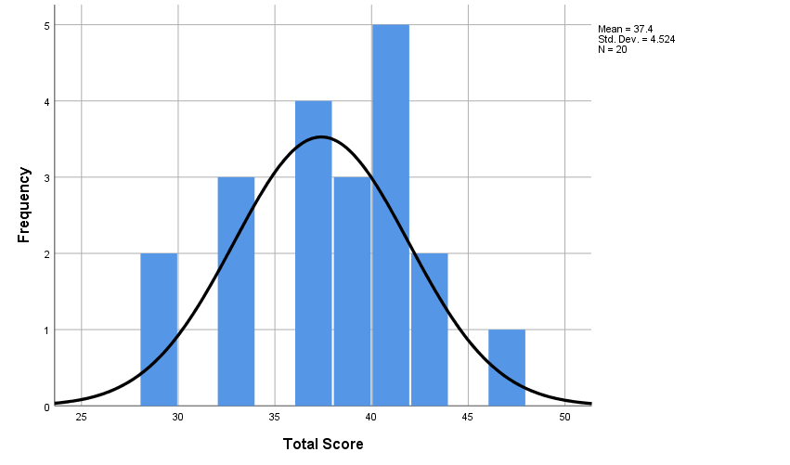

EXAMINE VARIABLES=Total BY Group
/PLOT=BOXPLOT
/STATISTICS=NONE
/NOTOTAL.
Explore
Notes
Output Created |  | 27-JUN-2019 15:16:34
Comments
Input | Data | C:\Users\300160287\Downloads\SPSS_file.sav
 | Active Dataset | DataSet2
 | Filter | <none>
 | Weight | <none>
 | Split File | <none>
 | N of Rows in Working Data File | 20
Missing Value Handling | Definition of Missing | User-defined missing values for dependent variables are treated as missing.
 | Cases Used | Statistics are based on cases with no missing values for any dependent variable or factor used.
Syntax |  | EXAMINE VARIABLES=Total BY Group  /PLOT=BOXPLOT  /STATISTICS=NONE  /NOTOTAL.
Resources | Processor Time | 00:00:00.44
 | Elapsed Time | 00:00:00.19

Group
Case Processing Summary
 | Group | Cases
 |  | Valid |  | Missing |  | Total
 |  | N | Percent | N | Percent | N | Percent
Total Score | Experimental Group | 11 | 100.0% | 0 | 0.0% | 11 | 100.0%
 | Control Group | 9 | 100.0% | 0 | 0.0% | 9 | 100.0%

Total Score

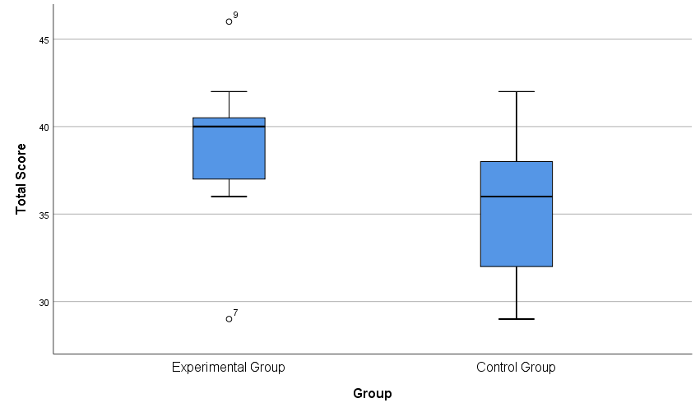

CROSSTABS
/TABLES=Group BY Gender Age
/FORMAT=AVALUE TABLES
/CELLS=COUNT
/COUNT ROUND CELL.
Crosstabs
Notes
Output Created |  | 27-JUN-2019 15:18:28
Comments
Input | Data | C:\Users\300160287\Downloads\SPSS_file.sav
 | Active Dataset | DataSet2
 | Filter | <none>
 | Weight | <none>
 | Split File | <none>
 | N of Rows in Working Data File | 20
Missing Value Handling | Definition of Missing | User-defined missing values are treated as missing.
 | Cases Used | Statistics for each table are based on all the cases with valid data in the specified range(s) for all variables in each table.
Syntax |  | CROSSTABS  /TABLES=Group BY Gender Age  /FORMAT=AVALUE TABLES  /CELLS=COUNT  /COUNT ROUND CELL.
Resources | Processor Time | 00:00:00.00
 | Elapsed Time | 00:00:00.01
 | Dimensions Requested | 2
 | Cells Available | 349496

Case Processing Summary
 | Cases
 | Valid |  | Missing |  | Total
 | N | Percent | N | Percent | N | Percent
Group * Gender | 20 | 100.0% | 0 | 0.0% | 20 | 100.0%
Group * Age | 20 | 100.0% | 0 | 0.0% | 20 | 100.0%

Group * Gender Crosstabulation
Count
 |  | Gender |  | Total
 |  | Female | Male
Group | Experimental Group | 6 | 5 | 11
 | Control Group | 5 | 4 | 9
Total |  | 11 | 9 | 20

DESCRIPTIVES VARIABLES=Age
/STATISTICS=MEAN STDDEV MIN MAX.
Descriptives
Notes
Output Created |  | 27-JUN-2019 15:20:55
Comments
Input | Data | C:\Users\300160287\Downloads\SPSS_file.sav
 | Active Dataset | DataSet2
 | Filter | <none>
 | Weight | <none>
 | Split File | <none>
 | N of Rows in Working Data File | 20
Missing Value Handling | Definition of Missing | User defined missing values are treated as missing.
 | Cases Used | All non-missing data are used.
Syntax |  | DESCRIPTIVES VARIABLES=Age  /STATISTICS=MEAN STDDEV MIN MAX.
Resources | Processor Time | 00:00:00.00
 | Elapsed Time | 00:00:00.01

Descriptive Statistics
 | N | Minimum | Maximum | Mean | Std. Deviation
Age | 20 | 19 | 66 | 27.40 | 12.102
Valid N (listwise) | 20

T-TEST GROUPS=Group(1 2)
/MISSING=ANALYSIS
/VARIABLES=Total
/CRITERIA=CI(.95).
T-Test
Notes
Output Created |  | 27-JUN-2019 15:22:14
Comments
Input | Data | C:\Users\300160287\Downloads\SPSS_file.sav
 | Active Dataset | DataSet2
 | Filter | <none>
 | Weight | <none>
 | Split File | <none>
 | N of Rows in Working Data File | 20
Missing Value Handling | Definition of Missing | User defined missing values are treated as missing.
 | Cases Used | Statistics for each analysis are based on the cases with no missing or out-of-range data for any variable in the analysis.
Syntax |  | T-TEST GROUPS=Group(1 2)  /MISSING=ANALYSIS  /VARIABLES=Total  /CRITERIA=CI(.95).
Resources | Processor Time | 00:00:00.00
 | Elapsed Time | 00:00:00.01

Group Statistics
 | Group | N | Mean | Std. Deviation | Std. Error Mean
Total Score | Experimental Group | 11 | 38.82 | 4.262 | 1.285
 | Control Group | 9 | 35.67 | 4.444 | 1.481

Independent Samples Test
 |  | Levene's Test for Equality of Variances |  | t-test for Equality of Means
 |  | F | Sig. | t | df
Total Score | Equal variances assumed | .413 | .529 | 1.614 | 18
 | Equal variances not assumed |  |  | 1.607 | 16.910

Independent Samples Test
 |  | t-test for Equality of Means
 |  | Sig. (2-tailed) | Mean Difference | Std. Error Difference
Total Score | Equal variances assumed | .124 | 3.152 | 1.952
 | Equal variances not assumed | .127 | 3.152 | 1.961

Independent Samples Test
 |  | t-test for Equality of Means
 |  | 95% Confidence Interval of the Difference
 |  | Lower | Upper
Total Score | Equal variances assumed | -.950 | 7.253
 | Equal variances not assumed | -.988 | 7.291

Appendix G
Articles
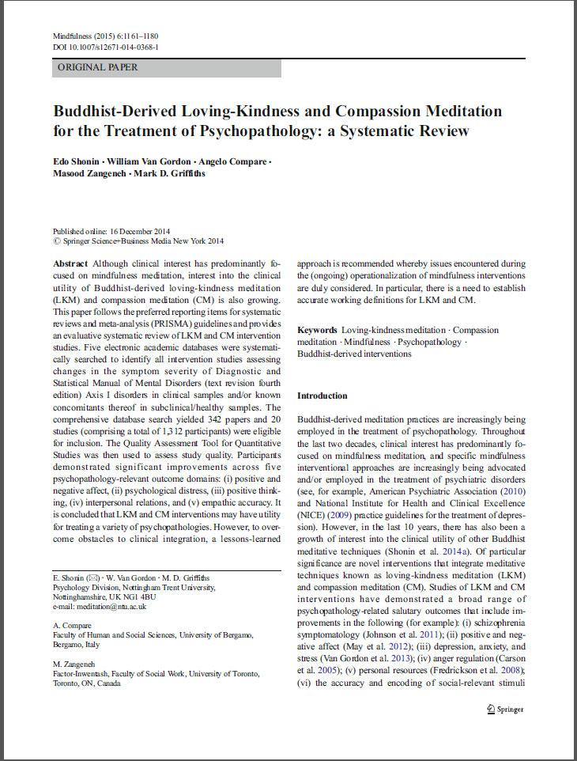
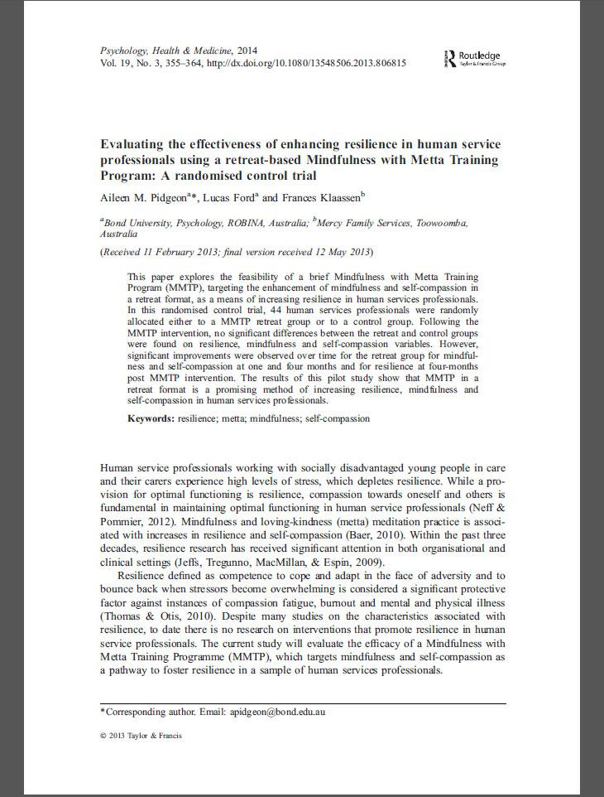
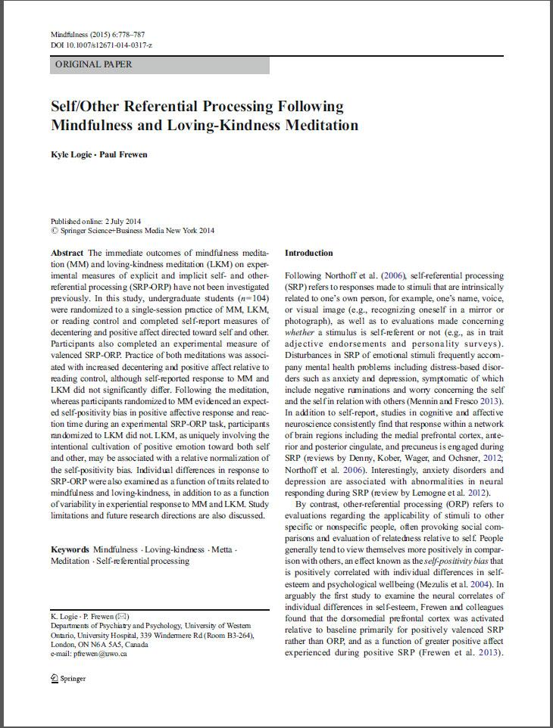
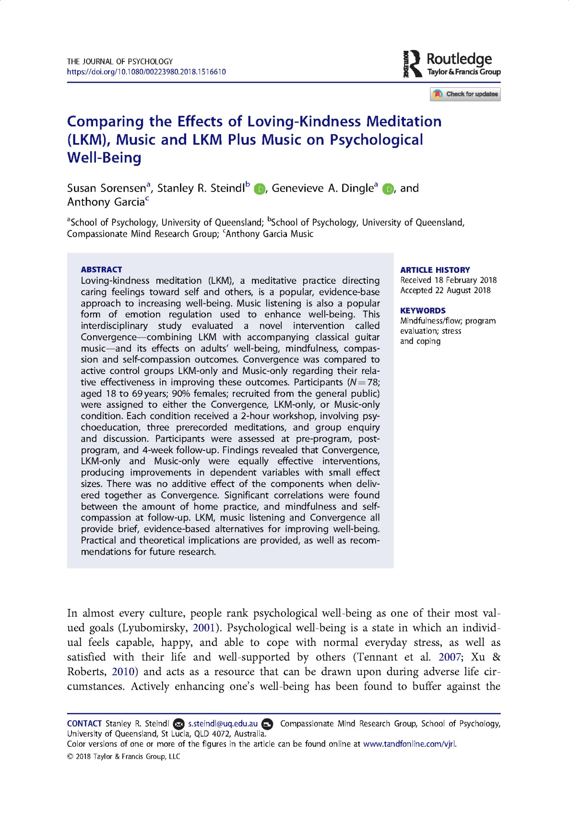
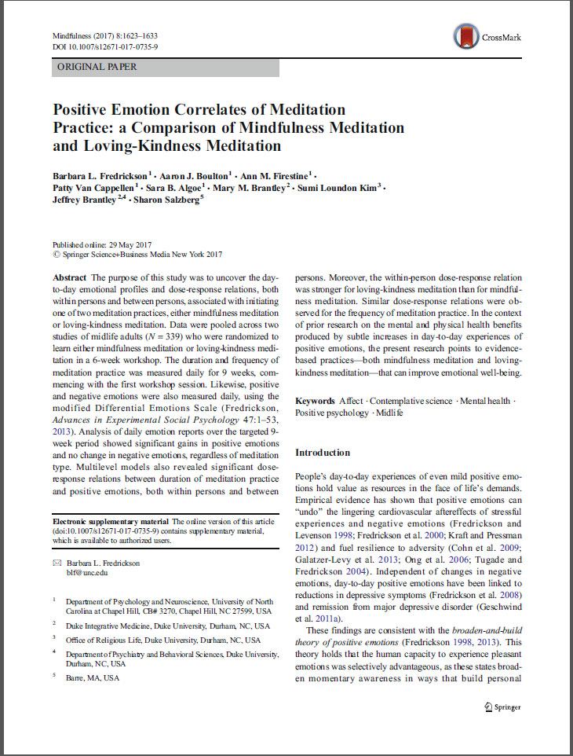
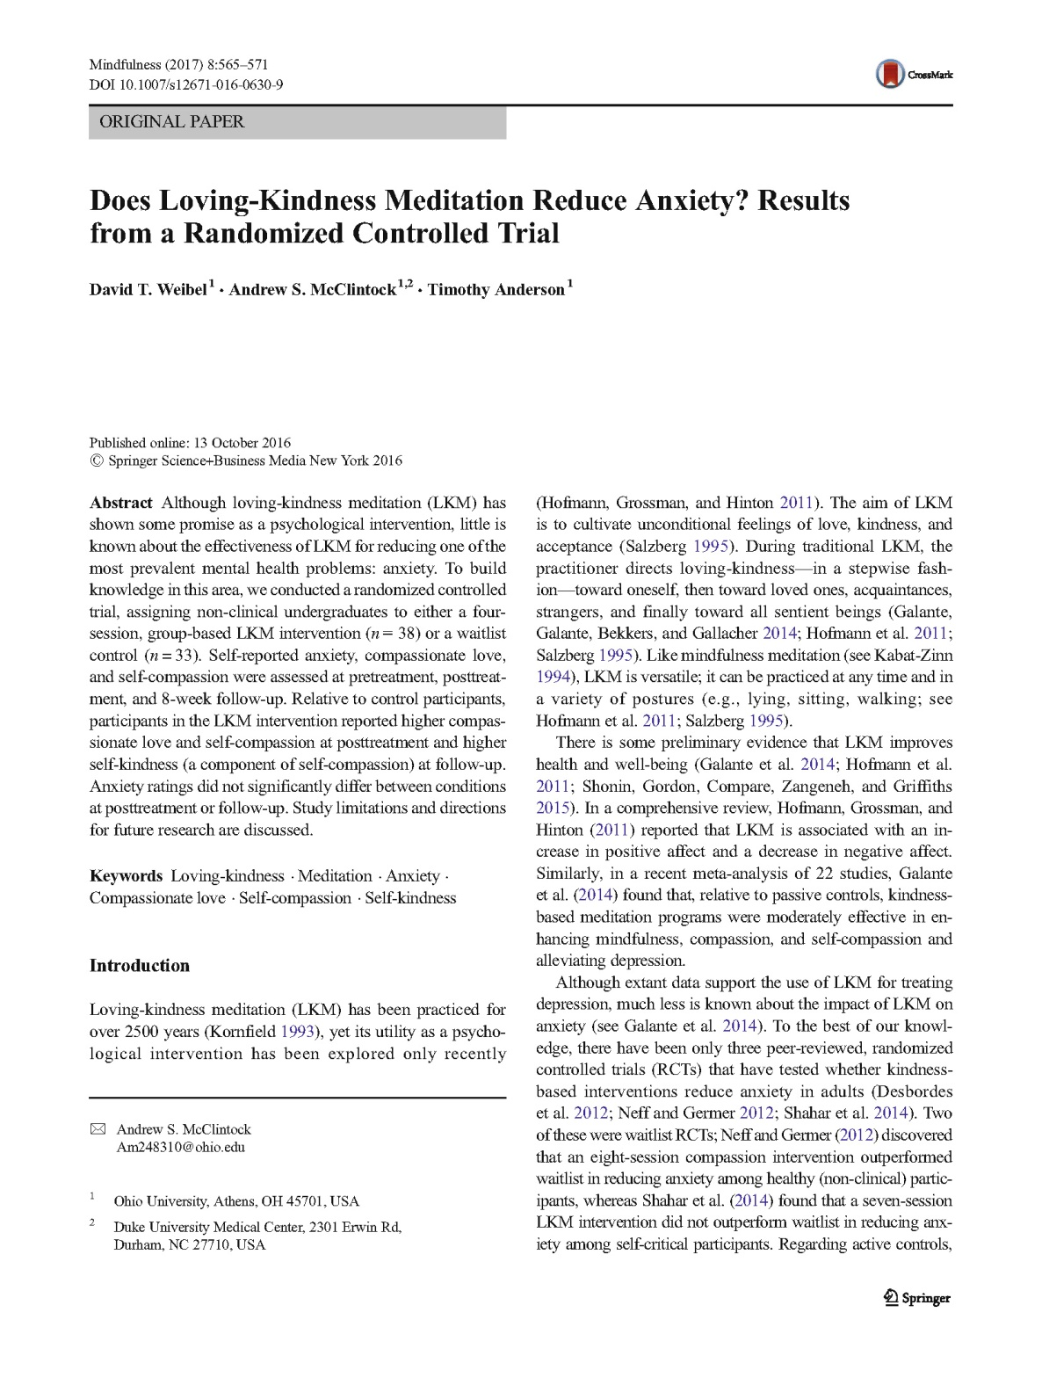

Appendix H
Ethics Approval
